Final requirement

Betel Leaf Organic Body Wash - 4000 từ

Tham khảo:
https://docs.google.com/document/d/1V-0wUohro8EsJME-emOBZ0k1q-XXGg-6thewztDEg1M/edit?tab=t.rf7xf158g69

https://www.canva.com/design/DAGwPlCjv1c/fv2bx4lu1s5H9uHxONOIYA/edit?utm_content=DAGwPlCjv1c&utm_campaign=designshare&utm_medium=link2&utm_source=sharebutton

Assessment criteria for the business plan:
Assessment criteria | Marks weight  (total 10 marks) | Details should be logical and include evidence-based arguments of the following contents (if any):
The business concept | 1 mark | - Product/service offerings  - Business strategy  - Business legal structure  - Other details (e.g. logo, location, facilities)
The marketing plan | 2 marks | - Industrial analysis  - Customer analysis  - Key competitor analysis  - Marketing 4Ps/7Ps
The Financial plan | 2 marks | - Start-up cost analysis  - Estimated revenue/ profit
The operation plan | 2 marks | - Human resources  - Key facilities  - Technology infrastructure  - Processes  - Supply chain
Other considerations  (if any) | 1 mark | - Legal issues  - Risk issues  - Sustainability issues
Creativity | 1 mark | - Creative ideas (e.g. newness, uniques of ideas)  - Visually attractive (e.g. using maps, figures, tables)  - Attention taking (e.g. artist presentation, attractive logo)
Plan structure/English | 1 mark | - Clear/ logical sequence of information  - Cited sources of information, references using Harvard citation style  - Spellings and grammar errors

PART | Detail | PiC | Deadline | DL
I. PROBLEM CONTEXT | 1. Overview market in Vietnam (Market size, Segmentation customer,...): kèm số liệu  2. Market gap  3. Potential product  4. Unit selling point | Hân | check lại đủ các ý, hợp lý chưa | 19/11
II. DESCRIPTION OF BUSINESS PROCESS | 1. Product/Service offerings  + Website, slogan, vision, mission, goals, branding and visual identity.  2. Business strategy (SMART goals, action plan for one year)  3. Business legal structure (Legal entity type, operating model) | Đạt | check lại đủ các ý, hợp lý chưa;  “action plan for one year” cần làm chính đúng với các thông số ở phần khác | 19/11
III. MARKETING PLAN | 1. Industrial analysis (5 forces)  2. Customer analysis  3. SWOT  4. Marketing mix (7Ps)  5. Competitor analysis (x)  5.1. Major competitors (Direct & Indirect competitors) | Quỳnh Ngân | tìm hiểu kĩ định nghĩa competitor để tránh nhầm lẫn định nghĩa thay thế | 19/11
IV. FINANCIAL PLAN | 1. Initial Capital & Funding  2. Costs Associated with Setting up the Business  3. Short-term Financial Plan  (co tinh toan ca revenue va profit)  4. Break-even Point Analysis  5. Long-term Financial Plan  (co tinh toan ca revenue va profit) | Hân  Phương |  | 19/11
V. OPERATION PLAN | 1. Human Resources  2. Key facilities  3. Technology Infrastructure  4. Operational Process  5. Supply chain management | Thu Ngân | lưu ý: ở chỗ operational process tại sao lại chọn 5 người vào 5 vị trí đó | 19/11
VI. OTHER CONSIDERATIONS | 1. Legal requirements and cooperation policies  2. Risk analysis and contingency planning  3. Assessment of model sustainability | Tâm Anh |  | 19/11
VII. REFERENCES

I. PROBLEM CONTEXT
1. Market Overview
1.1. Market size
The shower gel market in Vietnam is becoming a vital part of the beauty and personal care industry, with strong potential for steady growth in the coming years. According to Statista, Vietnam’s beauty and personal care market is forecasted to reach USD 2.74 billion by 2025, with a compound annual growth rate (CAGR) of approximately 3.26% from 2025 to 2029 [1]. Rising demand across both mass and premium segments has fueled the growth of shower gel products, which are now seen not only as daily hygiene essentials but also as lifestyle choices that deliver a more personalized and indulgent self-care experience for modern consumers.
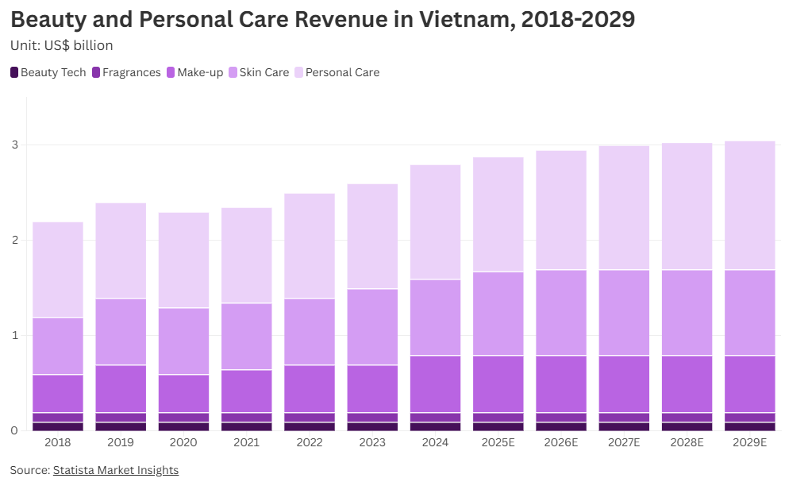
The global bath and shower products market size was valued at USD 51.17 billion in 2024. The market is projected to grow from USD 53.74 billion in 2025 to USD 79.96 billion by 2032, exhibiting a CAGR of 5.84% during the forecast period. Asia Pacific dominated the bath and shower products market with a market share of 38.23% in 2024.

As a fundamental element in maintaining personal health and hygiene, bath products have evolved from simple scrubbing soaps to novel bath salts and gels. The trend of aromatherapy has essentially supported the adoption of fragranced bathroom products owing to the rising concerns regarding body odor. Body washes and bath bombs infused with essential oils and floral scents are popular as they provide a spa-like experience. On the other hand, a strong consumer preference for intimate hygiene products such as Oriflame’s ‘Protecting Intimate Wash’ in developed markets is further likely to augment the growth of the market.
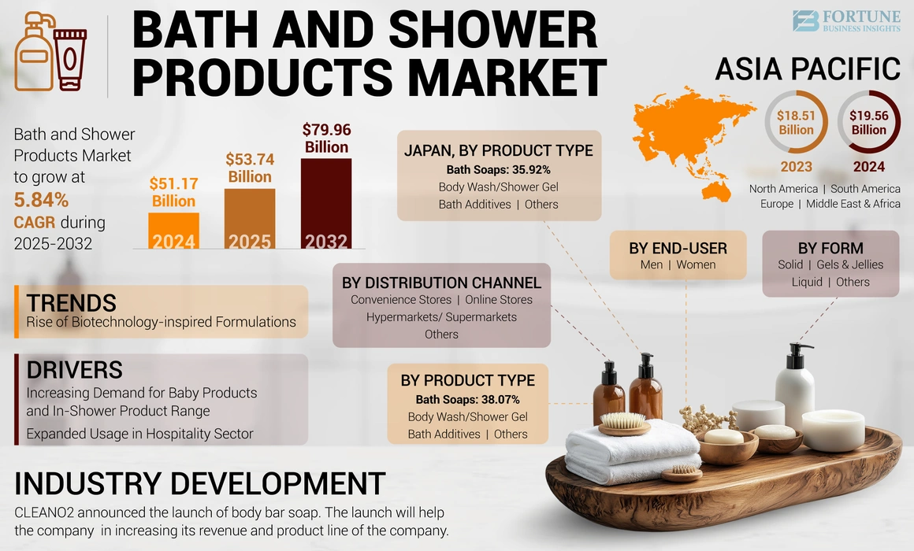
Table: Sales of Body Wash/Shower Gel Value 2018-2023
VND billion
 | 2018 | 2019 | 2020 | 2021 | 2022 | 2023
Bath and Shower | 3,843.5 | 4,101.4 | 5,202.2 | 4,897.4 | 5,168.8 | 5,462.6
Bar Soap | 831.8 | 859.0 | 1,072.9 | 902.4 | 888.9 | 903.4
Bath Additives | - | - | - | - | - | -
Body Powder | 30.8 | 30.6 | 29.1 | 26.8 | 29.2 | 31.6
Body Wash/Shower Gel | 2,469.7 | 2,643.5 | 2,775.7 | 2,859.0 | 3,069.0 | 3,269.9
Hand Sanitiser | 14.4 | 16.5 | 303.7 | 244.8 | 250.3 | 257.9
Intimate Hygiene | 390.0 | 430.9 | 456.8 | 429.4 | 469.1 | 509.3
- Intimate Washes | 390.0 | 430.9 | 456.8 | 429.4 | 469.1 | 509.3
- Intimate Wipes | - | - | - | - | - | -
Liquid Soap | 106.8 | 120.9 | 564.0 | 435.2 | 462.3 | 490.4
Source: Euromonitor International from official statistics, trade associations, trade press, company research, store checks, trade interviews, trade sources

The Body Wash/Shower Gel segment in Vietnam experienced steady and consistent growth from 2018 to 2023. Revenue increased from VND 2,469.7 billion in 2018 to VND 3,269.9 billion in 2023, representing an overall growth of about 32.4% with a compound annual growth rate of approximately 5.8%. Even during the pandemic period, the segment maintained positive momentum, reflecting its essential role in consumers’ daily personal care routines. The notable growth from 2021 to 2023 further highlights a clear shift in consumer preference from traditional bar soap to more convenient and premium liquid formats, positioning Body Wash/Shower Gel as a key driver of revenue within the bath and shower category.
1.2. Customer Segmentation
- Demographic segmentation:
- Age: Primary users range from 15–45 years old, with increasing adoption among older consumers due to growing awareness of skin health.

- Gender: Both male and female consumers, though women represent a larger share due to higher demand for skincare and fragrance-focused products. Men’s grooming lines are also expanding.

- Income level: Middle- to high-income groups are the main target, as body wash is perceived as more premium compared to bar soap.

- Geographic segmentation:
- Strongest demand in urban areas (Hanoi, Ho Chi Minh City, Da Nang): Prefer natural, organic, branded products, beautiful packaging, premium experience, willing to pay VND over VND 200,000 per unit for high-quality body washer.

- In rural areas, the adoption of organic body wash remains limited, The majority of rural customers still prioritize affordability (around VND 120,000 per unit) which makes the market penetration of organic body wash relatively slow compared to urban regions.

- Psychographic segmentation (psychology - lifestyle):
- Consumers value health, skin safety.
- Care about sustainability, environmental factors (green living, eco-friendly).
- Prefer products with organic certification, cruelty-free, natural ingredients.

- Behavioral segmentation (behavior):
- Use regular, completely replace regular soap/shower gel.
- High brand loyalty if trust in quality.
- Purchase decisions are influenced by: ingredients, certification, natural fragrance, environmentally friendly packaging.
- Often share experiences online, influencing the consumer community.

1.3. Distribution Channels
- Modern Trade (Modern retail channel):
- Supermarkets, shopping malls (Co.opmart, Lotte, AEON, VinMart).
- Chain of cosmetics & personal care stores (Guardian, Hasaki, BeautyBox).

- E-commerce (E-commerce):
- Major e-commerce platforms: Shopee, Lazada, Tiki.
- Brand online sales website.
- Social channels: Facebook, TikTok shop.

- Specialty Stores (Specialty stores):
- Organic/eco-friendly stores (Organica, Greenmart, L’Organic).
- Pharmacies, health and beauty stores.

1.4. Competition

- Natural/organic brands: Local brands such as Co mem HomeLab, Heebee, or international brands such as Lush are dominating the urban premium segment (VND 150,000–250,000 per unit) with eco-friendly products, but none of them contain Wedelia calendulacea or Betel leaves.
- Big brands: Lifebuoy, Safeguard (Unilever, P&G) dominate the synthetic focus on antibacterial and low price, but rarely use local herbs.
- Emerging niche competitors: Recently, small artisanal brands and online sellers on Shopee, Tiki, and Lazada have begun selling gel body wash. These brands target young, health-conscious consumers.

2. Market gap
2.1. Lack of clear differentiation

- The organic shower gel market is “similar” in formula: aloe vera, green tea, lavender...

- Few brands exploit betel leaves – a local ingredient, which has both antibacterial properties and traditional cultural elements.

2.2. Distribution Gap

- Mostly sold online or in large supermarkets.

- Lack of presence in pharmacies, convenience stores, green markets – where customers care about health and can easily buy daily products. Opportunity: Launch Betel Leaf Organic Body Wash affordable formats using local ingredients to reduce costs, distributed via local cooperatives and small retailers.
2.3. Communication Gap

- Organic communication is still vague, not emphasizing the specific uses of betel leaves.

- Not taking full advantage of TikTok channels, KOLs on natural beauty spread the story of "local, safe, different shower gel".

2.4. Organic certification

- Many brands in Vietnam are just “self-proclaimed natural/organic”, without clear certification.

- Gap: products can register for international organic certification (USDA Organic, Ecocert) or domestically to create trust.

3. Unique selling point
🌿 Ingredients & uses

- Betel leaf extract - a traditional Vietnamese ingredient, famous for its antibacterial, deodorizing, and natural cleansing properties.

- 100% organic - free of parabens, SLS/SLES, silicone, colorants, and synthetic fragrances.

- Gentle on sensitive skin - suitable for children, pregnant women, and postpartum women.

- Helps balance the skin - cleanses while maintaining natural moisture thanks to the combination of coconut oil/jojoba oil.

- Reduces skin inflammation & mild itching - taking advantage of the anti-inflammatory, antibacterial properties of betel.

🌸 Emotional experience

- "Bringing Vietnamese soul into the bathroom" - experience bathing with familiar folk ingredients.

- Fresh, unique scent - completely different from the popular Western floral scent.

- The feeling of bathing with fresh leaves – like a “natural spa” right at home.

- The combination of tradition & modernity – from folk medicine to organic cosmetics.

- Familiar but new – Vietnamese customers will find it familiar, international customers will find it unique.

🌍 Sustainability & society

- Environmentally friendly packaging – recyclable or biodegradable.

- Cruelty-free – suitable for green consumption trends.

- Community contribution – raw materials purchased from local farmers, supporting clean agriculture.

- Reduced environmental impact – water-saving production process, limiting plastic waste.

💎 Market positioning

- Differentiation – few organic shower gel brands exploit betel leaves.

- Suitable for many segments – can develop cheap mini bottles for students, large capacity for families.

- International organic certification (USDA, Ecocert) – increases credibility and makes it easier to access supermarkets and pharmacies.

- Targets health-conscious customers – mothers, people who eat clean and live green, people with chemical allergies.

- Positioning as “organic native to Vietnam” – competing differently with imported products.

1.https://www.vietnam-briefing.com/news/vietnam-beauty-personal-care-sector-market-entry.html

2. https://www.statista.com/outlook/cmo/beauty-personal-care/personal-care/shower-bath/vietnam?srsltid=AfmBOopNR8s3csQ08G4d9XkGfvuKjN6EElLayKKWkM-5BmQ9lf7RfCOp

3.
https://www.verifiedmarketresearch.com/product/body-wash-and-shower-gel-market/

II. DESCRIPTION OF BUSINESS IDEA

II. DESCRIPTION OF BUSINESS IDEA
1. Product/Service offerings
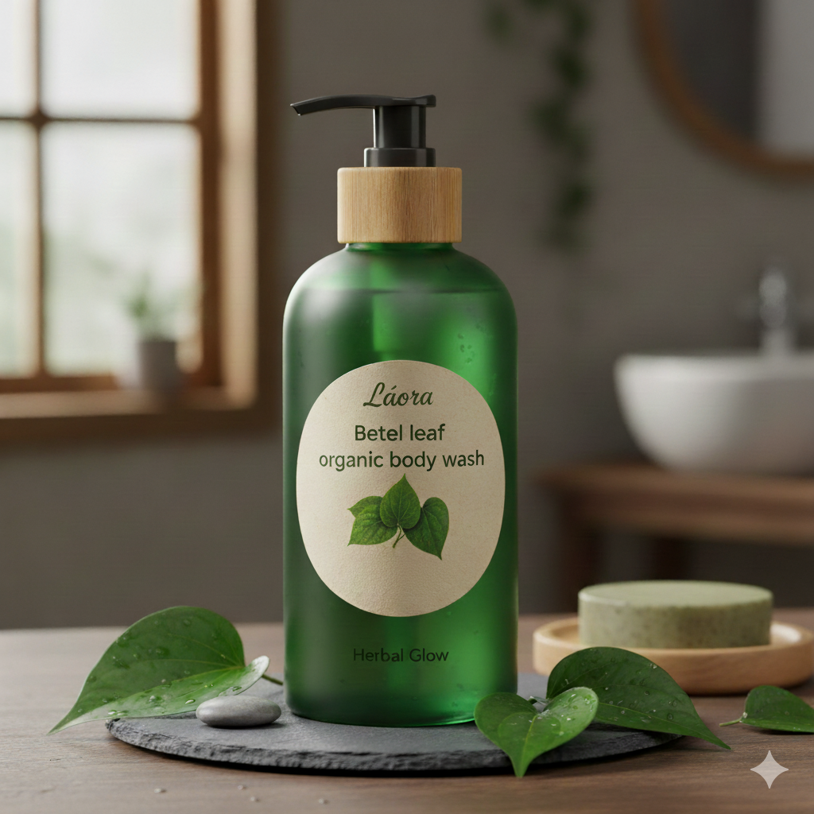
The slogan: "Betel Leaf: Revitalize & Purify - With Natural Botanicals"

1.1. Market Problem & Solution Summary: Láora - Betel Leaf Organic Body Wash
In today’s personal care market, consumers are increasingly concerned about the ingredients in the products they use every day. Many popular body washes contain synthetic chemicals that are not suitable for all skin types, which can cause skin irritation, dryness, or lead to long-term health concerns. At the same time, while demand for natural and organic products is growing, a large gap still exists: many “natural” products on the market lack authenticity, are not truly effective, or do not provide a premium body care experience. This makes it difficult and confusing for consumers to find products that are both safe, environmentally friendly, and enjoyable.

Láora - Betel Leaf Organic Body Wash may be one of the solutions to address consumers’ concerns at this time. Inspired by traditional herbal medicine, the product takes advantage of the natural antibacterial, purifying and soothing properties of organic betel leaves – an ingredient that has long been treasured in Asian health care methods. Combined with carefully selected natural ingredients, Láora offers a gentle yet effective cleansing solution that helps balance and protect the skin against harmful agents. Beyond skin care, the product also addresses growing environmental concerns through sustainable ingredients and eco-friendly packaging. In short, Láora offers a body wash that purifies and regenerates the skin without compromise - a safe, sustainable and enjoyable choice for health-conscious consumers.

1.2.. Entrepreneurial Storytelling
Every brand starts with a question. For Láora - Betel Leaf Organic Body Wash, “Why should we sacrifice the health and sustainability of the Earth for a daily body care product?”
The entrepreneurial journey began with a personal struggle - the founder couldn’t find a truly natural body wash that was safe for sensitive skin, but also felt indulgent rather than compromising.
Láora created a body wash that was not only truly organic, but also rooted in tradition and cultural wisdom. Inspired by the ancient use of betel leaves in Asian health care - with natural antibacterial and purifying properties. Each body wash bottle is a combination of heritage and innovation: premium botanical formulas, gentle cleansing, skin regeneration, and respect for both people and nature.
Láora’s story is about more than solving a problem - it’s about redefining everyday self-care as a way of living green. By choosing sustainable ingredients, prioritizing eco - friendly packaging, and upholding a commitment to transparency, Láora is more than just a product. It’s a movement toward conscious living, where beauty, health, and the environment are all in harmony.
Láora's entrepreneurial journey proves that with passion, authenticity, and a transformative vision, even a seemingly ordinary product like shower gel can become extraordinary - becoming a symbol of refined enjoyment and sustainable living.

1.3. Vision, mission and Core values
Vision: To be the leading sustainable personal care brand, redefining everyday self-care by combining heritage-inspired natural ingredients with modern innovation - creating healthier lifestyles for everyone and a greener future for the planet.
Mission: Our mission is to provide authentic organic body care solutions that leverage the natural benefits of betel leaves and other herbs. We are committed to creating safe, effective and environmentally friendly products, while empowering consumers to embrace health and sustainability in their daily routines.
Core values:
Láora always puts authenticity as the foundation for all products. In the context of the cosmetics and personal care market, there are many brands labeled as “organic” or “natural” but still using chemical ingredients, Láora commits to transparency and absolute loyalty to organic raw materials. This not only builds trust with consumers but also affirms the brand value associated with authenticity, clarity and prestige.
The brand recognizes that the personal care industry is not just about beauty, but also has a direct impact on the environment. Therefore, Láora prioritizes clean, sustainably sourced ingredients and applies eco-friendly packaging. Every detail in the production process is carefully considered to minimize negative impacts on the ecosystem, thereby contributing to the goal of protecting the Earth in the long term.
Láora also offers a product with a philosophy of healthy and balanced living. The brand values ​​the health of consumers, ensuring that the product is safe for even sensitive skin. Moreover, Láora promotes comprehensive well-being, where daily bathing is not only about cleaning but also about relaxing, regenerating energy and taking care of the spirit. This is the factor that helps Láora create a different value compared to mass products on the market.

1.4. Branding & Visual Identity
Logo Description: The logo on the Láora Betel Leaf Organic Body Wash bottle is minimalistic yet rich in naturalness. The center is the image of a dark green betel leaf, symbolizing purification, freshness and traditional oriental herbs. Surrounding the leaf is a stylized circle with small dots, symbolizing circulation, balance and the harmonious connection between humans and nature. The word “LÁORA” is written in bold capital letters, creating a strong and luxurious feeling, while the sub-text (BETEL LEAF – ORGANIC BODY WASH) is designed in a modern, clear and easy-to-read style, bringing an overall balance between nature and sophistication.

Brand Voice & Character: Láora brand brings warmth, naturalness and elegance, conveying a trustworthy message about green, clean and sustainable lifestyle. The way the brand connects with customers is gentle, close but still scientific and modern, aiming at the balance between body care and environmental protection. From there, Láora carries a clean green natural image, emphasizing safe organic ingredients, elegance, sophistication and aiming at luxurious minimalism, not only caring for the user experience but also accompanying the sustainable values ​​of society.

2. Business strategy
SMART goals

Smart Criteria | Goal detail in 6 months
Specific | Deploy a multi-channel communication campaign (Facebook, Instagram, TikTok) with content revolving around the benefits of organic betel leaves. Boost sales via Shopee, Lazada and TikTok Shop.
Measurable | Get 10,000 followers/6 months ~ 1666 followers/ a month ~ 420 followers/ a week
Achievable | Have a marketing budget, a content team and mid-range micro KOLs, organize 2-3 advertising campaigns to attract customers and product trials with many attractive gifts and have local distribution partners ready to cooperate.
Relevant | Láora aims to enhance the new organic brand image to ensure its initial position in the market. Furthermore, creating safe products also helps retain customers, increase lifetime value and importantly, increase the credibility of the organic brand to link with environmental commitment & organic positioning.
Time-bound | 6 months following the product's official release date, which is anticipated to be between the end of October 2025 and April 2026.

Action plans for 1 year

Time | Main actions | Specific actions | Expected result
Month 1 - 3 | Preparing to launch the brand and Campaign | Phase one includes designing logos, packaging, identity guidelines and building websites and stores on Shopee, Lazada, TikTok Shop.  Phase two will deploy the "Natural Purification" campaign, using prepared content (photos, videos), combining with KOLs/Micro Influencers and promoting on Facebook & TikTok Ads to create a viral effect and reach potential customers. | Complete the identity and get ready to sell online. Achieve ≥ 20,000 reach, 2,000 interactions.
Month 4 - 5 | Boost online sales, Loyalty Program (Trial) | Launch Flash Sale campaigns on Shopee, Lazada and Livestream sales on TikTok to boost short-term sales. At the same time, you will create savings combo packages to encourage customers to shop more. In the long term, the “Green Care” customer care program (accumulating points, vouchers) and sending customer care emails & SMS to those who have purchased two or more times will help increase the return rate and build a loyal customer community. | Increase online revenue by 15% compared to 3 months previous, Have ≥ 200 participating customers.
Month 6 - 8 | Expand offline channels | Connect with 10 reputable organic cosmetic stores and spas to bring products into their systems. At the same time, organizing product experience booths at cosmetic fairs will help you reach potential customers directly, giving them the opportunity to try and experience your organic betel leaf products. | Have ≥ 10 new points of sale.
Month 9 - 10 làm | Brand storytelling | Produce a video series that documents the entire journey from betel leaf cultivation to the finished organic product. At the same time, publishing in-depth blog posts on natural skin care will not only provide useful information but also affirm the value and difference of the brand. | Get ≥ 100,000 video views.
Month 11 | Boost peak sales | Run big promotions on two key shopping occasions, 11/11 and Black Friday. At the same time, you need to cooperate with Influencers to have them conduct reviews and review products, helping to increase credibility and attract customers' attention. | Revenue increased ≥ 30% compared to previous months.
Month 12 | Summary and extension | Analyze data to evaluate the effectiveness of marketing and sales campaigns that have been implemented. At the same time, conducting customer surveys will help you better understand their experience with the product. Based on the data and feedback collected, you will plan to expand your product portfolio with potential new products such as shampoo or body lotion. | Product orientation 2026

3. Business legal structure

3.1. Legal Entity Type

3.1.1. Recommended Entity Type: Limited Liability Company (LLC)

Láora - Betel Leaf Organic Body Wash will be established as a Limited Liability Company, providing the optimal balance between operational flexibility, legal protection, and growth potential for a premium organic personal care brand.
Strategic Advantages Analysis:
Business Aspect | LLC Benefits | Impact on Láora
Brand Credibility | Official legal status enables professional partnerships with major retailers and distributors. | Facilitates entry into premium organic market segments and partnerships with Guardian, Hasaki, VinMart.
Regulatory Compliance | Streamlined compliance with cosmetic regulations and organic certification processes. | Essential for obtaining required certifications (USDA Organic, Ecocert) and regulatory approvals.
Risk Management | Limited liability protection separates personal assets from business obligations. | Protects founders while testing innovative betel leaf formulations and market expansion.
Scalability | Enables professional team building, investor attraction, and strategic partnerships. | Supports evolution from startup to established organic brand with regional expansion capability.
Supply Chain Control | Formal contracting capabilities with suppliers and manufacturing partners. | Ensures consistent quality of certified betel leaf and other organic ingredients.

3.2. Operation Model
Organic betel leaf shower gel is produced on a medium scale, combining basic modern technology and manual control processes to maintain the quality and naturalness of each product. The main ingredients are betel leaves and Wedelia chinensis, harvested from local herb gardens and certified for safety. Each stage from extraction, mixing to packaging strictly adheres to hygiene standards, is environmentally friendly and safe for users.
The product will be widely distributed on online channels (website, Shopee, Lazada) and some spas and stores specializing in natural products. Order management, inventory control and customer care are operated by a simple but effective management system, helping to optimize time and enhance the shopping experience. All marketing and customer service activities are implemented internally, to bring sincerity, consistency and closeness in every interaction.

3.3. Business Model Canvas

THE BUSINESS MODEL CANVAS
Key Partners  -Local herbal farmers & cooperatives (Betel leaf, Wedelia chinensis).  -Organic handmade cosmetics workshop.  -NanoKOCs (1,000–10,000 followers) – authentic reviews.  -E-commerce platforms: Shopee, Lazada, Sendo, Tiktok  -Spas & green consumer stores (consignment partners).  -Eco-friendly domestic logistics unit. | Key Activities  -Purchasing & processing organic ingredients.  -Manual production and packaging combined with basic technology.  -Quality control & safety/organic certification.  -Online sales & inventory management.  -Green marketing & communication through KOC/KOL  -Customer care & building a green consumer community. | Value Propositions  -Organic shower gel extracted from betel leaves, safe & benign.  -Natural ingredients, no toxic chemicals.  -Environmentally friendly from raw materials to packaging.  -Bringing a green - healthy - natural skin care experience.  -Suitable for modern consumers, concerned about health & the environment. | Customer Relationships  -Real-time support via chat and social media platforms  “Láora Care” loyalty program with exclusive rewards  -Engaging campaigns: giveaways, mini-games, and polls  - Encourage genuine feedback & reviews from customers.  - Fast support & personalized experience. | Customer Segments  -Diverse consumers (17–40 years old) interested in organic & green living.  -Young families prioritize safe, benign products for the skin.  -Customers of spas & stores specializing in natural products.  -Average-high income consumers in large cities.
 | Key Resources  -Exclusive formula of betel leaf extract & Wedelia chinensis.  -Organic raw materials that meet safety standards.  -Handcrafted production team & quality control experts.  “Organic – green – natural” brand.  -Online sales system & selective distribution channels. |  | Channels  -Direct sales via official website  Shopee and Lazada online storefronts  Facebook and Instagram for marketing and direct sales  -Offline consignment through partner spas and local stores
Cost Structure  Ingredient sourcing: betel leaves and natural oils  Labor and production expenses  Marketing costs (NanoKOC, social media, green content).  Packaging and domestic shipping  Website upkeep and platform transaction fees  Cost of safety certification, organic, trademark registration. |  | Revenue Streams  -Direct sales via website & e-commerce platform.  -Consignment revenue at spa & organic store.  -Gift combo & natural skin care product package.  -Niche market revenue: corporate customers (green gifts, organic spa).

III. MARKETING PLAN

III. MARKETING PLAN - Quỳnh Ngân
1. Porter 5 forces in competitors analysis
Competitor: LIFEBUOY (by Unilever)

Force | Intensity | Impact on Your Brand | Notes
Competitive Rivalry | Very High | Very High | Market leader, wide coverage, strong promotions, affordable price.
Threat of New Entrants | Low | Low to Moderate | High barriers, but organic niche leaves room.
Threat of Substitutes | Moderate to High | Moderate to High | Growing shift to natural/organic and handmade products.
Bargaining Power of Buyers | High | High | Price-sensitive consumers, low brand loyalty, easy switching between brands.
Bargaining Power of Suppliers | Low | Low | Unilever controls the supply chain globally, suppliers have minimal power.

Table. : LIFEBUOY Porter 5 forces
Competitive Rivalry
Lifebuoy has one of the strongest brand positions in Vietnam’s body wash and antibacterial soap segment. Its reputation is built on health protection, with a deep reach into both rural and urban markets. Competing directly on “germ protection” is challenging because Lifebuoy owns that narrative. For your betel leaf shower gel, a better route is to highlight natural antibacterial benefits with skincare advantages, focusing on wellness and organic living rather than pure hygiene claims.
Threat of New Entrants
The FMCG sector has significant entry barriers: heavy advertising, retail shelf dominance, and long-term consumer trust. For Lifebuoy, this keeps most new competitors at bay. Still, niche players can enter by targeting gaps that Lifebuoy doesn’t cover, such as organic, eco-friendly, or skin-sensitive solutions. Your product can find its space by stressing “safe for skin, natural origin, and sustainable sourcing.”
Threat of Substitutes
Substitutes include herbal bar soaps, natural handmade cleansers, and even alternative hygiene products like foam washes. With consumers increasingly shifting toward organic and herbal-based care, traditional chemical formulas face growing pressure. This creates a strategic opening: your brand can position betel leaf as a natural antibacterial alternative while delivering gentleness that substitutes don’t guarantee.
Bargaining Power of Buyers
Consumers trust Lifebuoy but remain highly price-driven. Switching costs are low, and loyalty is tied to the product category (hygiene) rather than to the brand itself. For your premium-priced organic shower gel, this means customers will only pay more if they clearly see value beyond hygiene — such as skin-friendly, eco-conscious, or unique Vietnamese ingredients.
Bargaining Power of Suppliers
Backed by Unilever, Lifebuoy has global sourcing power and minimal supplier dependency. In contrast, your brand will operate on a smaller scale with higher per-unit costs. Yet, this can be reframed as an advantage: locally sourced betel leaves, small-batch production, and community farming can become authentic selling points that strengthen your brand’s differentiation.

Competitor: HAZELINE (by Unilever)

Force | Intensity | Impact on Your Brand | Notes
Competitive Rivalry | High | Moderate | Strong in whitening/beauty; you can stand out with organic antibacterial focus.
Threat of New Entrants | Moderate | Moderate | Supported by Unilever, Hazeline holds strong advantages. Yet, the natural skincare niche is still open for new players.
Threat of Substitutes | Moderate | Moderate | Herbal soaps and eco-friendly care pose both risks and opportunities.
Bargaining Power of Buyers | High | High | Price-sensitive yet shifting toward safe, natural ingredients.
Bargaining Power of Suppliers | Low | Low | Global supply chain; your local betel leaf can be a unique edge.

Table. : HAZELINE Porter 5 forces
Competitive Rivalry
Hazeline is well-known in Vietnam for its affordable skin-brightening and natural-ingredient image, often positioned as a beauty-oriented soap/body wash. The brand appeals to younger consumers and women who want fair, smooth skin. For your product, competing directly on beauty benefits like whitening is risky, since Hazeline dominates that space. Instead, you could position your shower gel around antibacterial care plus skin wellness — something Hazeline is weaker in.
Threat of New Entrants
While Hazeline benefits from Unilever’s strong distribution and marketing, it is not as deeply entrenched in the “health protection” narrative as Lifebuoy. This leaves more room for smaller players to enter with unique propositions, especially in the organic and herbal niche. Your betel leaf shower gel can stand out by emphasizing natural antibacterial benefits combined with safe skincare, differentiating from Hazeline’s focus on beauty whitening.
Threat of Substitutes
Substitutes include herbal handmade soaps, DIY skincare, and other natural cosmetic products targeting the same demographic of young, beauty-conscious women. As consumers increasingly prefer eco-friendly, gentle, and chemical-free skincare, Hazeline faces competition from herbal-based solutions. For your brand, this trend is favorable: you can combine organic wellness with functional skin care to compete against both Hazeline and substitutes.
Bargaining Power of Buyers
Hazeline’s customers are often price-sensitive and trend-driven, willing to experiment with new brands if they promise natural or safe beauty benefits. This means your brand could attract these buyers, but only if it offers a unique story (Vietnamese herb tradition, organic farming) or visible skincare improvements. Otherwise, buyers will remain with Hazeline’s low-cost, well-marketed products.
Bargaining Power of Suppliers
Hazeline, like Lifebuoy, benefits from Unilever’s global supply chain, giving it stable sourcing at scale. Your brand may not achieve the same cost advantage, but by highlighting local, natural ingredients like betel leaf, you can convert supplier relationships into part of your brand authenticity — something Hazeline cannot easily claim.
Competitor: ENCHANTEUR

Force | Intensity | Impact on Your Brand | Notes
Competitive Rivalry | Moderate | Low | Focuses on fragrance, not antibacterial.
Threat of New Entrants | Moderate | Moderate | Branding strong, but niche organic still open.
Threat of Substitutes | High | Moderate | Alternatives: perfume, body mist, herbal soaps.
Bargaining Power of Buyers | High | Moderate | Price-sensitive but willing to try niche organic.
Bargaining Power of Suppliers | Low | Low | Generic inputs, local organic can differentiate.

Table. : ENCHANTEUR Porter 5 forces
Competitive Rivalry
Enchanteur is positioned as a romantic, fragrance-driven brand, often associated with femininity and elegance. It attracts women seeking affordable luxury and scented body care. For your product, competing directly on fragrance and sensual branding is difficult, since Enchanteur dominates that perception. Instead, you could differentiate by focusing on health-related benefits — antibacterial, organic, and skin-safe qualities — which Enchanteur does not emphasize.
Threat of New Entrants
Although Enchanteur benefits from strong branding and distribution, the fragrance-focused market is competitive and does not fully cover the growing herbal/organic skincare demand. This leaves space for new entrants who highlight safety, eco-friendliness, or cultural authenticity. Your betel leaf shower gel can stand out in this gap by positioning itself as natural antibacterial care with wellness benefits.
Threat of Substitutes
Substitutes are strong for Enchanteur, as consumers can easily switch to perfumes, body mists, or herbal soaps that also provide fragrance. However, this is also an opportunity: your brand can attract consumers who want multifunctional solutions — both scent and skin protection — while promoting natural antibacterial care.
Bargaining Power of Buyers
Buyers of Enchanteur are often young women who value price and fragrance variety. They are highly selective but also open to trying new products if they perceive added value. Your organic shower gel can appeal to this group by emphasizing transparency, safety, and heritage. Without these, buyers may default to Enchanteur’s affordable, fragrance-rich products.
Bargaining Power of Suppliers
Enchanteur relies on common fragrance ingredients that are widely available in the market, giving it stable supplier relationships. Your brand, while smaller, can leverage local and unique betel leaf sourcing as both a story and a differentiator. This supplier connection can become a marketing strength, something Enchanteur cannot easily replicate.

2. Customer Analysis
Customer Analysis
5. Competitor analysis: Major competitors (Direct & Indirect competitors)

Type | Competitor name | Description | Price
Direct (Domestic products) | Cocoon Vietnam, NauNau, Cỏ Mềm | Local Vietnamese brands emphasizing natural and herbal skincare. Products often use ingredients like green tea, lemongrass, turmeric, or essential oils. Appeal to eco-conscious and health-focused consumers looking for gentle, chemical-free body wash. | Cỏ Mềm: ~175,000 VND/bottle (350ml)  NauNau:210,000 VND/bottle( 300ml)  Cocoon: 190,000 – 220,000 VND/bottle (500ml)
Indirect (Foreign products) | Lush (England), Love Beauty & Planet (Unilever Global), The body shop (UK) | Global brands offering sustainable or organic body care. Focus on cruelty-free, vegan, eco-friendly positioning. Available in Vietnam via official stores and e-commerce. Though not herbal/traditional, they attract a similar target group of natural lifestyle consumers. | Lush: 300,000 – 400,000 VND/bottle  Love Beauty & Planet: ~200,000 – 270,000 VND/bottle( 400ml)  The body shop: 200,000 – 250,000 VND/bottle( 250ml)

Table. : Direct & Indirect competitors Analysis
Betel Leaf Organic Body Wash is a competitive and distinctive choice in Vietnam’s personal care market, especially as consumers increasingly value natural, skin-safe, and eco-conscious products. The shower gel highlights several strengths:
- Native Herbal Ingredient – Betel Leaf: Traditionally used in Vietnam for its natural antibacterial and cleansing properties, betel leaf becomes a safe and effective alternative to harsh chemicals, well-suited for daily use.
- Safe for Sensitive Skin: The organic formulation avoids parabens, sulfates, and artificial fragrances, making it gentle for all skin types, including children and sensitive skin.
- Eco-conscious and Sustainable: Packaged with recyclable, minimalist materials that reduce plastic waste while enhancing the product’s “green” image.
- Affordable Premium Choice: Positioned at a reasonable price point compared to imported organic shower gels, while still delivering premium natural benefits.
- Emotional Connection – “Tradition Meets Wellness”: Beyond just hygiene, the product carries cultural value, turning a familiar Vietnamese herb into a modern wellness choice that resonates with local pride and sustainable living.
Thiếu:
3. SWOT
4. Marketing mix (7Ps)

IV. FINANCIAL PLAN
IV. Financial budget plan
4.1. Initial Capital & Funding
Financial budgeting is a significant element when starting any project, especially a startup project. Allocating capital and resources properly as well as effectively can support the project run smoother as cash flow pressure is reduced through cash flow planning and assumptions. Moreover, it also helps in assessing the potential and feasibility of a project.
Through this plan, the business aims to ensure efficient allocation of resources, maintain cost control, and forecast realistic financial outcomes. The ultimate goal is to achieve sustainable growth and profitability while supporting the brand’s commitment to natural, eco-friendly skincare products made from local Vietnamese herbs.

Member | Contributed capital
Trịnh Thị Yến Phương | VND 5,000,000
Lưu Trần Tâm Anh | VND 5,000,000
Trần Thị Hân | VND 5,000,000
Nguyễn Quỳnh Ngân | VND 5,000,000
Hoàng Thị Thu Ngân | VND 5,000,000
Nguyễn Thành Đạt | VND 5,000,000
Total | VND 30,000,000

4.2. Start-up Cost: Setting up the Business Costs
Through the research process, to establish a business — especially one related to cosmetics such as natural soap — the main costs include business registration fees, intellectual property registration fees, production and circulation licensing fees, as well as costs for product sampling, testing, and quality inspection.
According to current regulations (Decree No. 139/2016/NĐ-CP, amended and supplemented by Decree No. 22/2020/NĐ-CP), newly established enterprises or those commencing business activities for the first time are exempt from the business license tax (lệ phí môn bài) for the first year of operation.
Since this enterprise was established in September 2025, it will be exempt from the business license tax for the remainder of 2025 (from the establishment date until December 31, 2025). The license tax obligation will begin from January 2026.
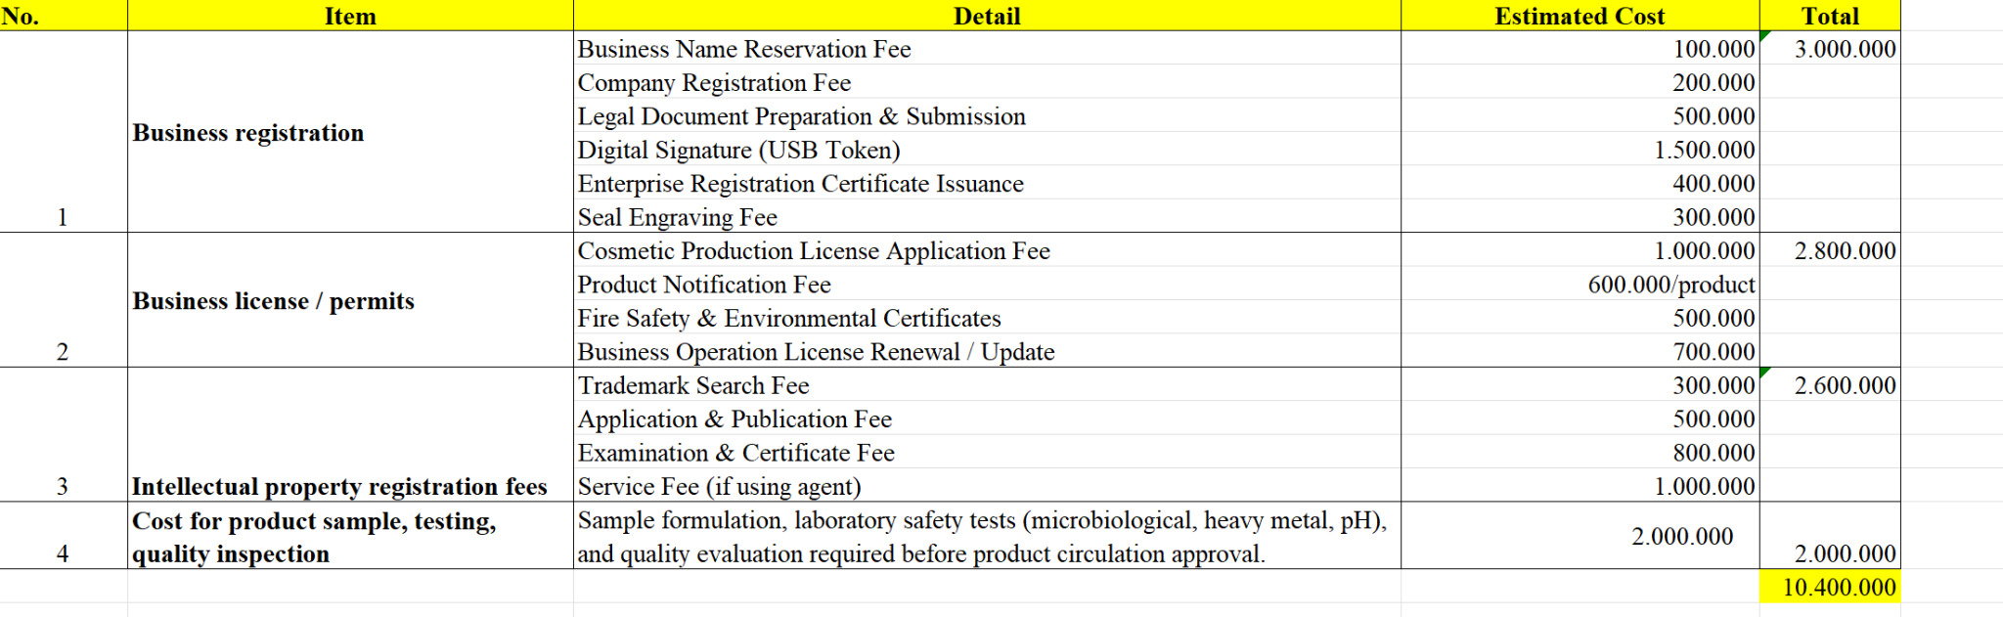
4.3. Short-term financial plan
Trong phần này, kế hoạch tăng trưởng và kế hoạch tài chính sẽ được chia thành hai kịch bản như sau : Kịch bản tích cực và Kịch bản tiêu cực - nhằm quản lý tốt hơn về rủi ro và những yếu tố không chắc chắn
- Ở kịch bản tích cực, với sự hỗ trợ từ các chiến dịch digital mạnh mẽ và các chương trình Flash Sale việc mở rộng thêm các điểm bán hàng offline cùng với những dịp khuyến mại lớn hàng tháng và Black Friday, thì số lượng sản phẩm bán ra dự kiến sẽ tăng trung bình 15% mỗi tháng đạt tổng cộng là 4 980 sản phẩm trong năm đầu tiên
- Ở kịch bản tiêu cực trong trường hợp hiệu quả của marketing và tốc độ mở rộng kênh offline diễn ra chậm hơn dự kiến thì doanh số sẽ được dự báo tăng khoảng 9% mỗi tháng, tương ứng với khoảng 3 420 sản phẩm được bán ra trong 12 tháng đầu tiên
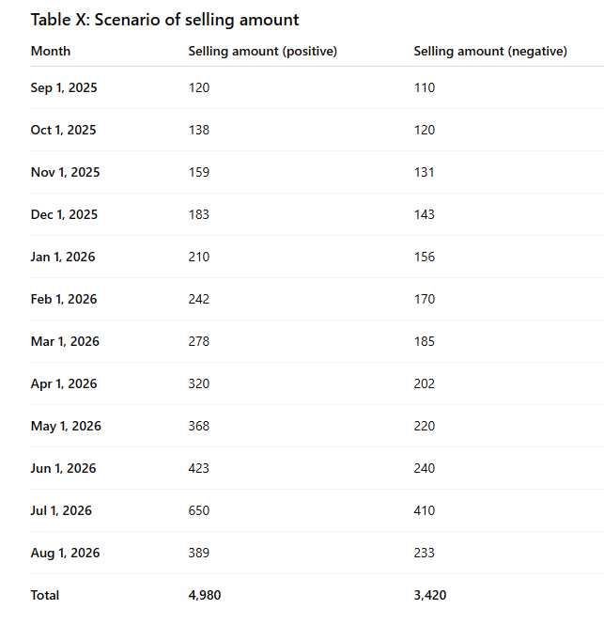
Ngoài ra, chi phí để sản xuất xà phòng Láora sẽ bảo gồm : lá trầu tươi, nước cất thảo mộc, chất tạo gel tự nhiên, dầu dưỡng và bao bì chai PET có vòi pump. Theo đó, giá nguyên liệu lần lượt là 80.000 VNd cho 1 lít chiết xuất lá trầu, 70.000 VND cho 1 lít nước cất thảo mộc, 95.000 VND cho 1 kg chất tạo gel tự nhiên và 6.000 - 8.000 VND cho mỗi chai PET 250ml
Dựa trên mức nguyên liệu để sản xuất 100 chai sữa tắm 250 ml, tổng chi phí của nguyên liệu sẽ đưa vào sản xuất là 4.850.000 VND. Như vậy, chi phí để sản xuất mỗi chai sữa tắm vào khoảng 48.50VND
Các thiết bị như bình khuấy, máy khuấy mini hay phễu chiết được khấu hao theo nhiều lần sử dụng nên sẽ không được tính trực tiếp vào giá vốn hàng bán nhằm giúp giá thành mỗi chai sữa tắm ổn định và tối ưu hơn trong dài hạn
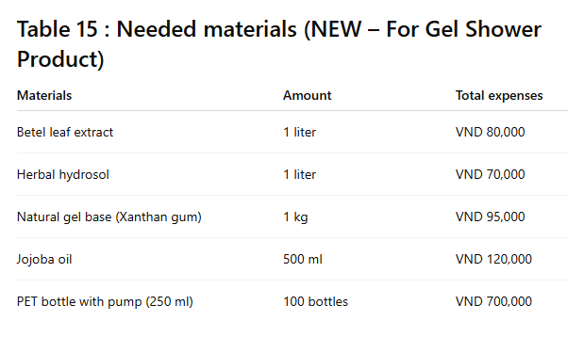
4.3.1 cost structure
Cơ cấu chi phí trong năm đầu tiên sẽ thể hiện được toàn bộ các khoản đầu tư cần thiết cho dự án sữa tắm thiên nhiên Láo ra theo từng tháng. Với các khoản chi phí chính bao gồm: giá vốn bán hàng (COGS), chi phí bán hàng và tiếp thị, chi phí quản lý chung (G&A) chi phí nghiên cứu và phát triển sản phẩm (R&D), và các chi phí vận hành khác cuối cùng là thuế.
Trong tháng đầu tiên - giai đoạn chuẩn bị sản phẩm, xây dựng nhận diện thương hiệu và chạy chiến dịch ra mắt- các khoản chi phí được ước tính cụ thể như sau:
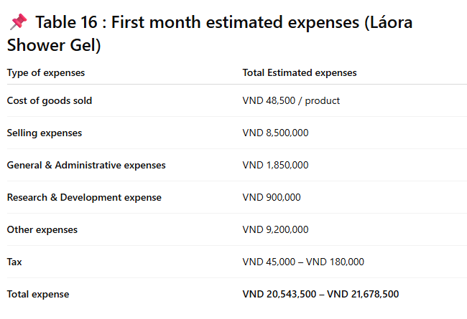
Trong các tháng tiếp theo, các khoản chi phí của dự án sẽ được ước tính dựa trên tỷ lệ phần trăm của doanh thu thực tế, kết hợp với kế hoạch phân bổ ngân sách cho các hoạt động như marketing, vận hành và mở rộng kênh bán hàng theo từng giai đoạn của chiến dịch 12 tháng. Cụ thể, chi phí bán hàng sẽ tăng cao vào các tháng triển khai chương trình khuyến Flash Sale, Livestream và mùa cao điểm như các ngày sale mỗi tháng - Black Friday, trong khi chi phí quản lý chung sẽ được duy trì ở mức ổn định hằng tháng.
Đối với thuế, các nghĩa vụ thuế của dự án sẽ được tính theo quy định pháp lý hiện hành và dựa trên lợi nhuận phát sinh trong quá trình vận hành. Riêng đối với thuế giá trị gia tăng (VAT), dự án giả định rằng doanh nghiệp được khấu trừ 55% thuế đầu vào vì phần lớn các nguyên liệu, bao bì và vật tư phục vụ sản xuất sữa Láora đều có hóa đơn VAT hợp lệ.
Trong năm 2025 - là năm đầu tiên doanh nghiệp bước vào hoạt động - thương hiệu Láora được miễn lệ phí môn bài theo quy định. Do đó, khoản lệ phí môn bài 2.000.000 VND sẽ chỉ được nộp vào đầu năm 2026
Dựa trên kế hoạch chi tiêu theo từng tháng, cơ cấu giá vốn sản xuất (COGS), chi phí bán hàng - marketing, chi phí quản lý và các khoản thuế phát sinh, tổng chi phí hoạt động trong năm đầu tiên của dự án sẽ được xác định như sau:
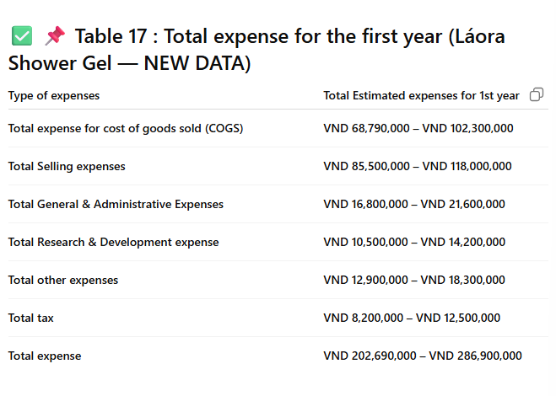
4.3.2 revenue and profit analysis
Trong năm đầu tiên, doanh thu của dự án sẽ được ước tính dựa trên số lượng sản phẩm sữa tắm Láora bán ra theo hai kịch bản. Lợi nhuận được tính toán dựa trên giá bán dự kiến, giá thành sản xuất ( 48.500 VND/chai).
Ở mỗi kịch bản sẽ có sự chênh lệch về chi phí marketing, sản lượng tiêu thụ và tốc độ tăng trưởng hàng tháng cũng sẽ tạo ra mức doanh thu và lợi nhuận khác nhau, phản ánh được khả năng thích ứng của dự án trong điều kiện thị trường thuận lợi hoặc kém thuận lợi. Do đó, phân tích này giúp đánh giá rõ hơn hiệu quả tài chính của dự án và khả năng đạt lợi nhuận trong năm đầu hoạt động
Positive Scenario : Doanh thu và lợi nhuận của dự án có xu hướng cải thiện ổn định theo từng tháng nhờ tốc độ tăng trưởng sản lượng trung bình là 15% mỗi tháng và hiệu quả từ các chiến dịch marketing được triển khai. Trong tháng đầu tiên hoạt động (9/2025), dự án ghi nhận lỗ khoảng 11 - 13 triệu đồng, chủ yếu là do chi phí xây dựng thương hiệu, sản xuất lô hàng thử nghiệm và các chi phí quảng cáo. Đây là mức lỗ phổ biến của các startup mỹ phẩm thiên nhiên ở giai đoạn khởi đầu do chi phí lớn nhưng doanh thu còn thấp
Từ tháng 12/2025, nhờ lượng khách hàng tăng dần và hiệu ứng từ chiến dịch “Natural Purification”. Doanh thu đạt khoảng 22 triệu đồng và lợi nhuận ròng ước tính khoảng 5,5 triệu đồng, đánh dấu bước đầu thời điểm dự án chính thức có lãi. Từ đây, các chỉ số tài chính được cải thiện đáng kể khi doanh thu tăng nhanh hơn chi phí nhờ quy mô bán hàng mở rộng và chi phí marketing trên mỗi đơn vị sản phẩm giảm theo thời gian.
Bước sang năm 2026, lợi nhuận ròng tăng đều qua từng tháng, đặc biệt mạnh trong giai đoạn các ngày Flash Sale, livestream và bán hàng vào mùa cao điểm mua sắm như sale hàng tháng - Black Friday. Biên lợi nhuận dần chuyển từ mức âm trong những tháng đầu sang mức dương ổn định và đạt khoảng 19% - 23% vào tháng 8/2026, phản ánh sự tối ưu hóa chi phí và khả năng vận hành hiệu quả hơn của dự án
Bên cạnh đó, tỷ suất hoàn vốn (ROI) cũng thể hiện xu hướng tăng trưởng rõ rệt, bắt đầu mạnh lên từ đầu năm 2026 và có thể đạt khoảng 28% - 34% vào cuối năm, cho thấy doanh nghiệp đang khai thác tốt chi phí đầu tư ban đầu và tạo ra các giá trị tài chính bền vững
Nhìn chung, kịch bản tích cực cho thấy dự án sữa tắm thiên nhiên Láora có khả năng phục hồi nhanh sau giai đoạn khởi động, mô hình tài chính ổn định, và tiềm năng mở rộng lớn trong thị trường mỹ phẩm thiên nhiên. Điều này chứng minh rằng dự án này hoàn toàn phù hợp để tiếp tục đầu tư và mở rộng sản phẩm, phát triển hệ thống phân phối trong những giai đoạn tiếp theo.
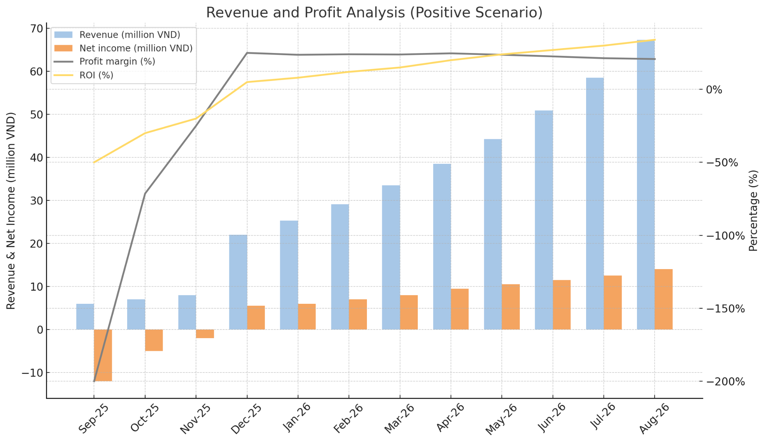
Negative Scenario :

V. OPERATION PLAN

Entrepreneur & Management Team
a. Entrepreneur (Nhà sáng lập)
[Founder's Name], the Founder and CEO, is the driving force behind Betel Leaf Organic Body Wash. With [number] years of experience in the cosmetics and personal care industry, they bring a deep understanding of product development, market trends, and consumer needs. Their skill set combines strategic leadership with a keen eye for product innovation, allowing them to transform a simple vision into a viable business. Motivated by a passion for traditional Vietnamese remedies and a desire to create a natural, safe body care product, the founder's vision is to build a brand that not only delivers exceptional quality but also embodies a commitment to health and sustainability for the community.

b. Management Team (Ban quản lý)
Our management team is built on a foundation of complementary skills and shared strategic vision, crucial for bringing our project to life. We have a lean yet highly effective group, comprising key experts in essential business functions.
The team for "Betel Leaf Organic Body Wash" combines practical experience with a clear understanding of the market. We believe this diversity of expertise will create a powerful synergy, ensuring our product not only has superior quality but also effectively reaches its target audience.
- Marketing & Sales Director: With deep experience in digital marketing and brand building, this individual will be responsible for positioning our product in the market. They will lead creative campaigns, from telling the story of our organic, betel leaf-based product to building customer trust through online and offline channels

- Production & R&D (Research & Development) Director: This expert has a strong background working in cosmetic labs and certified manufacturing facilities. They will ensure that the entire production process adheres strictly to organic standards, from selecting raw materials and developing the formula to the final quality control check, guaranteeing every product is safe and highly effective.

c. Organizational Structure
CEO (Business Lead): The CEO is the primary visionary and strategist. Their role is to set the overall direction for "Betel Leaf Organic Body Wash," from defining the brand's mission to securing funding and forming key partnerships. This includes a crucial focus on sourcing organic ingredients and building relationships with local farmers or suppliers. They will also be the final decision-maker on all major strategic and financial matters.

CFO (Financial Lead): This person is responsible for all financial aspects of the company. Their responsibilities include developing and managing the budget, tracking costs associated with raw materials (betel leaves, organic oils), production, packaging, and marketing. The CFO will manage cash flow, create financial forecasts, and handle all accounting to ensure the business remains financially healthy and sustainable.

CLO ( Logistic Lead ) The Logistic Lead, or CLO, is in charge of Laora’s entire physical value chain, from sourcing to delivery. This role involves managing all supplier relationships and overseeing the end-to-end supply chain to prevent disruptions. A key function is controlling the inventory of both raw materials and finished goods, while managing all aspects of order fulfillment and logistics to ensure products reach customers efficiently.

CMO (Marketing & Sales Lead): The CMO's main goal is to build and grow the "Betel Leaf Organic Body Wash" brand. They will create and execute a compelling brand story that highlights the product's natural ingredients and traditional heritage. This role involves managing all digital marketing campaigns, social media content, and public relations. They are also responsible for driving sales by establishing e-commerce platforms and partnerships with retail stores, spas, or organic markets.

COO (Operations Lead): The COO oversees the day-to-day operations and supply chain. This is a critical role for an organic product. They will manage the entire production process, from sourcing high-quality betel leaves and other organic materials to overseeing manufacturing and quality control. The COO ensures that every bottle of body wash meets our quality standards and that the logistics, inventory, and distribution are efficient and reliable.

Thiếu:
2. Key facilities

3. Technology Infrastructure

4. Operational Process

5. Supply chain management

VI. OTHER CONSIDERATION

